Creating branch and merging using Git Hub
- Check your pwd→
- Go to your folder in d drive
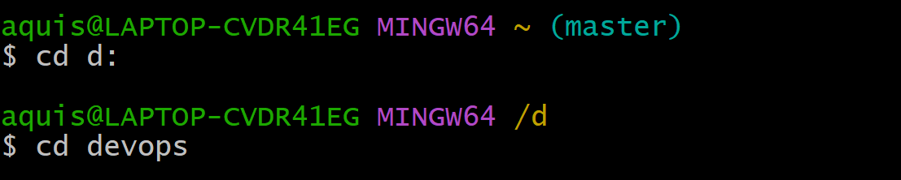
- Go to repository which is there in your folder and check status
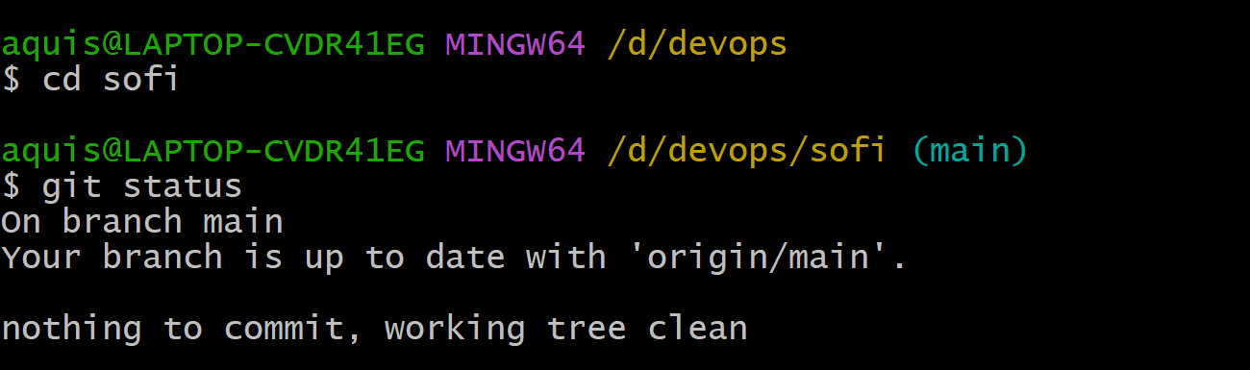
Here we can see branch is up to date whatever we did on our git hub page.
- Now to see main branch, we write a following code as:
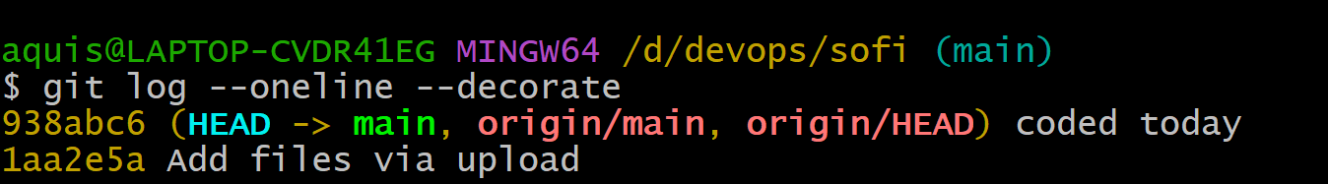
We can see here “head” is a main which is a local master→ that means our head is in main
- Lets create a new branch →
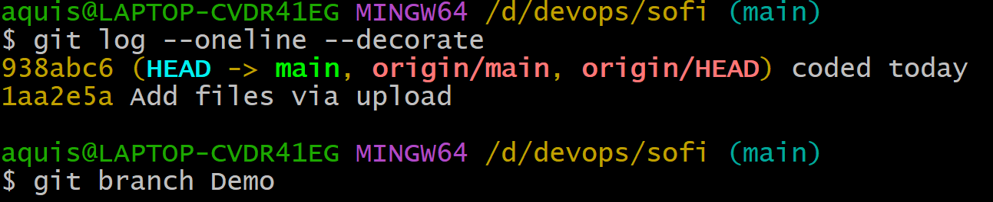

- The above branch we have created on local ---- we have not yet uploaded on git hub
You can go to git hub page and check there is only one branch.
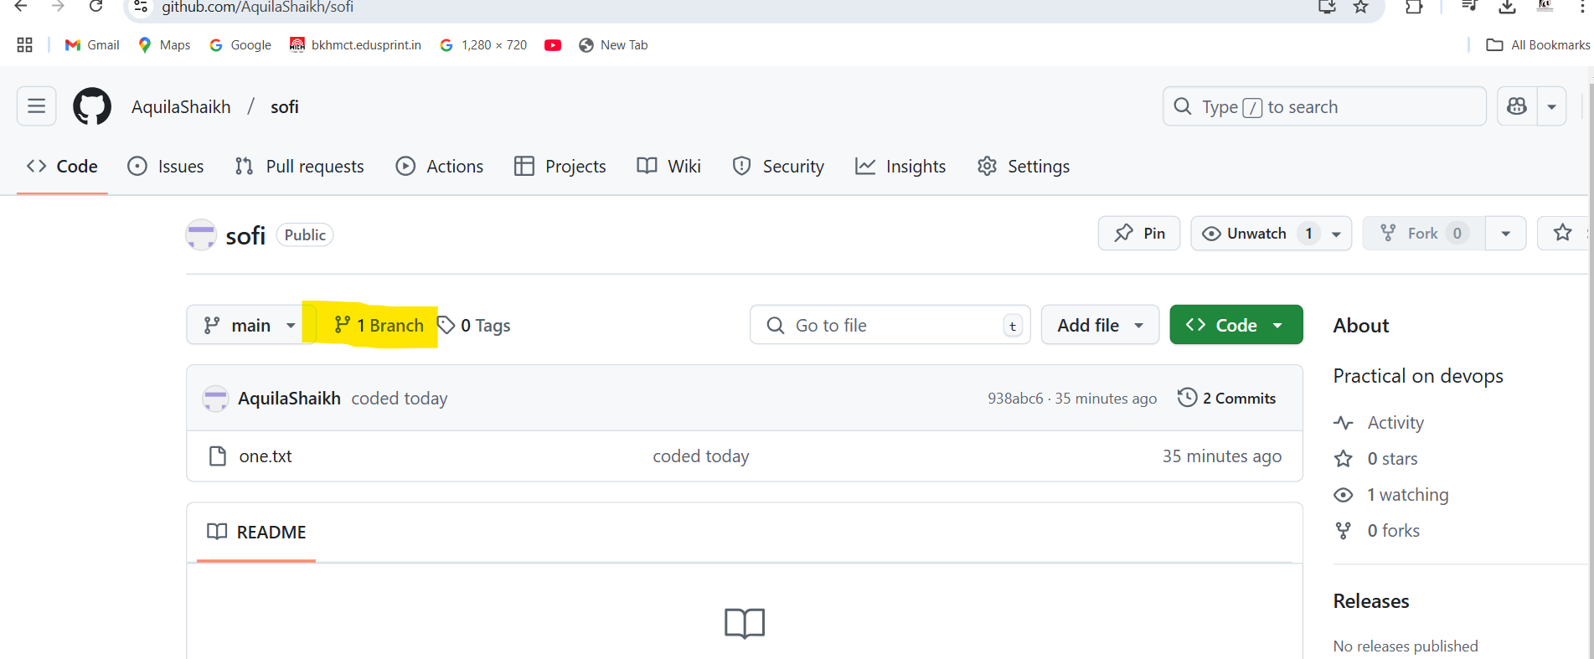
- Now check status →
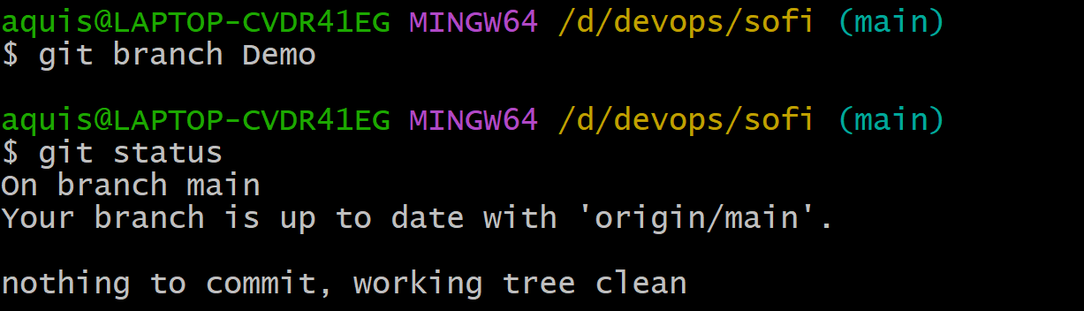
- Nothing to Comit
- Now check log status→
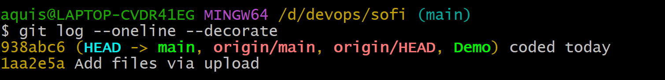
Here we can see head is having “main” branch as well as “Demo” branch
- To perform any changes to a particular branch we need to go to that branch
- Moving to branch “Demo” usinng checkout command
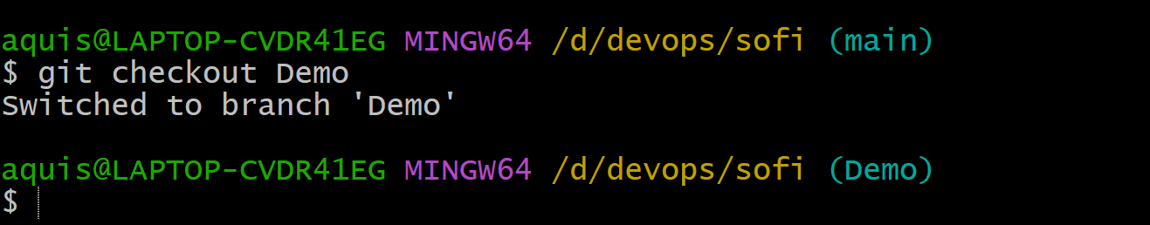

- We can also use git status command to check , we are on which branch
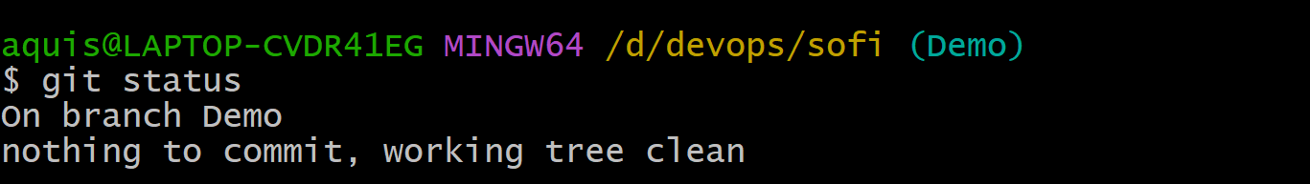
- If we do a log , we can see that we are on “Demo” branch
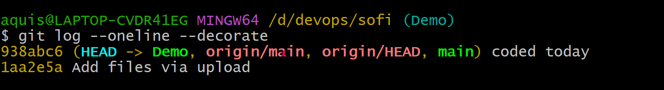
Note: there is no difference between “main” branch and “Demo” branch → both are same
- Lets create a new file in “Demo” branch
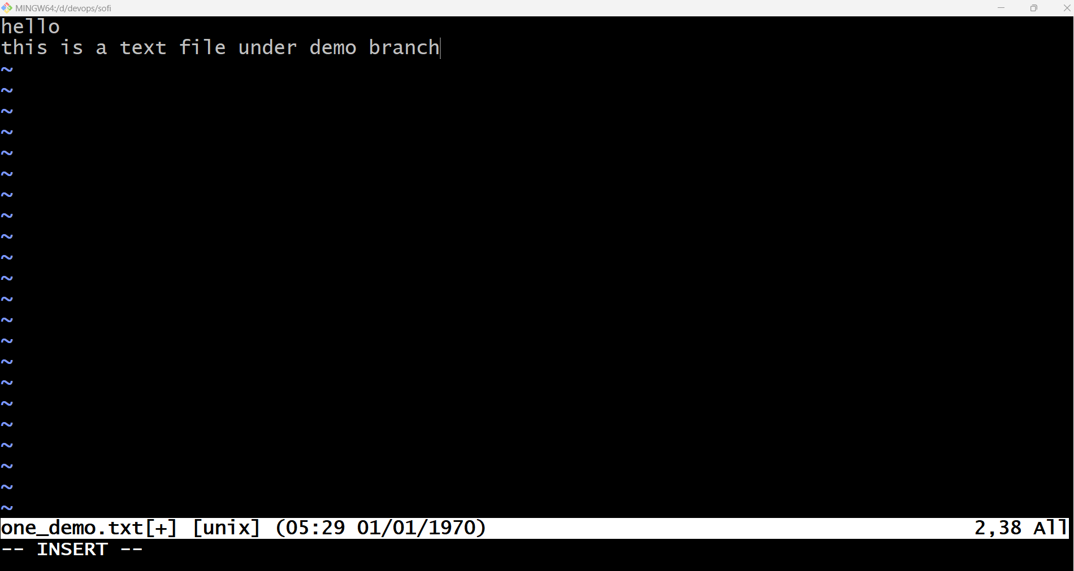
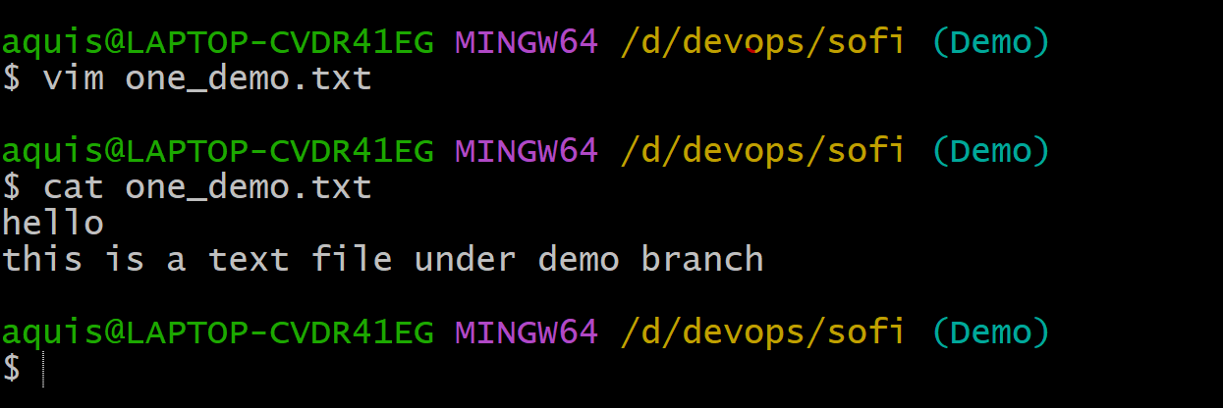
- Check status
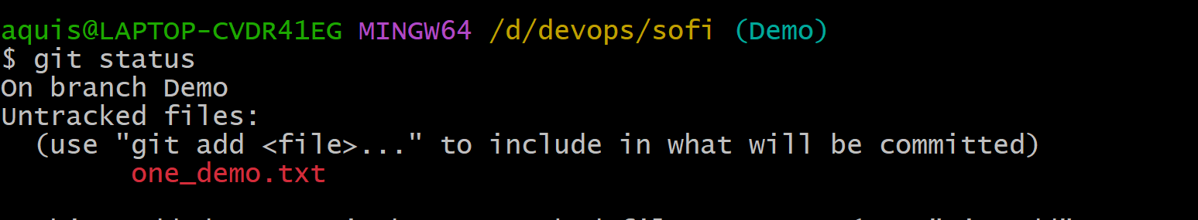

- Add “one_demo.txt” file
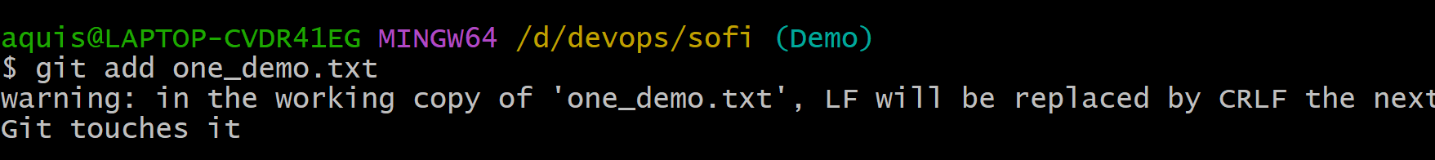

- Again check status
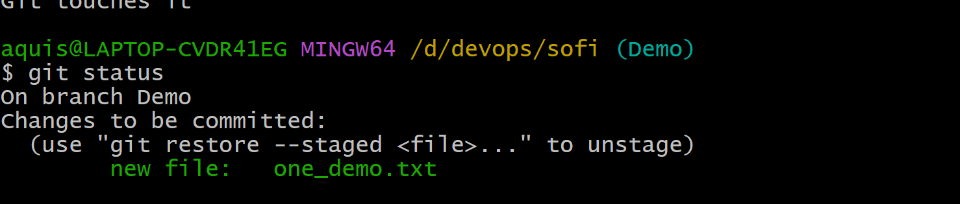
- “one_demo.txt” file is in staged state
- Perform Commit
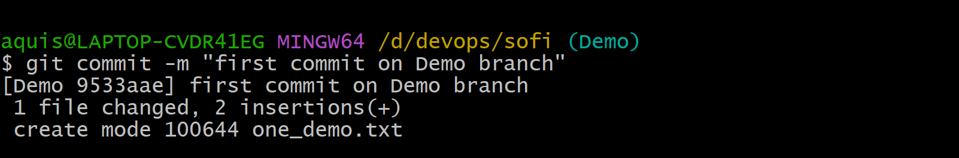
- Check status

- Git status is clean
- Check log
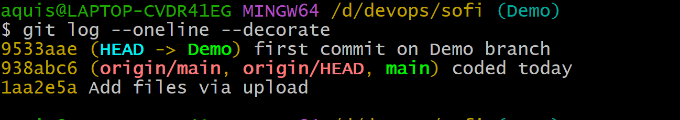
- Head is in “Demo”. Origin main and main are at the other place.

- Go to github and check…. It is showing only one branch
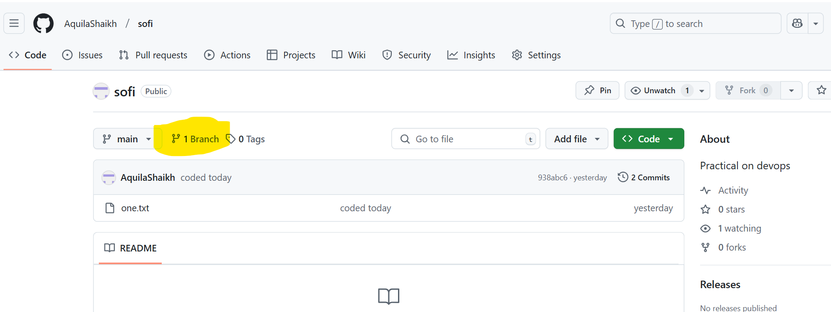
- Now upload the branch on git hub using “Push” command.
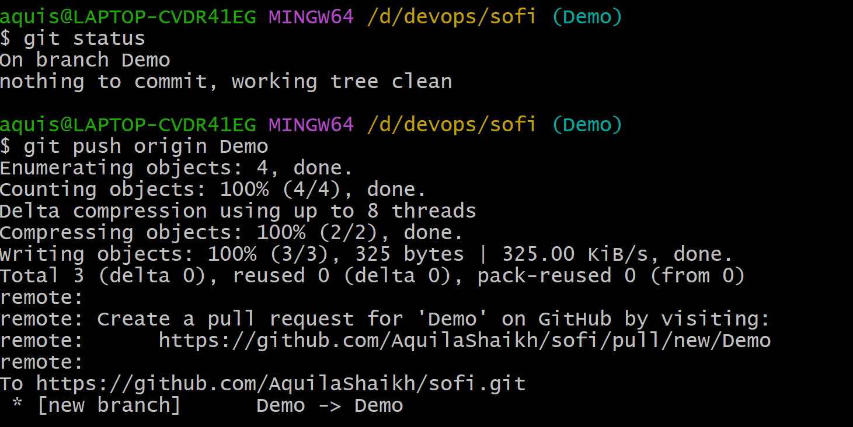
- Go to git hub and refeesh the page, you will be able to see 2 branches.
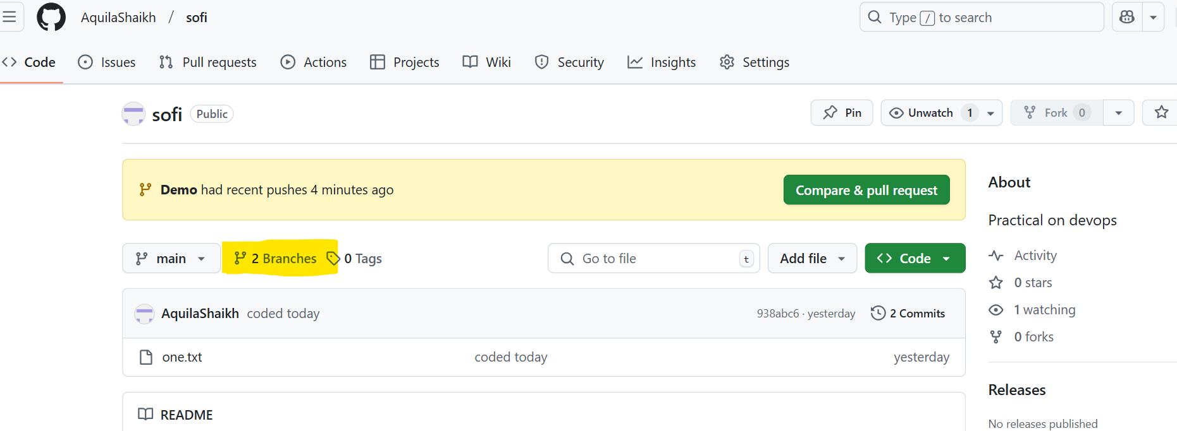

- Go to “insight” and click on “network”, you will be able to see our “Demo” branch.
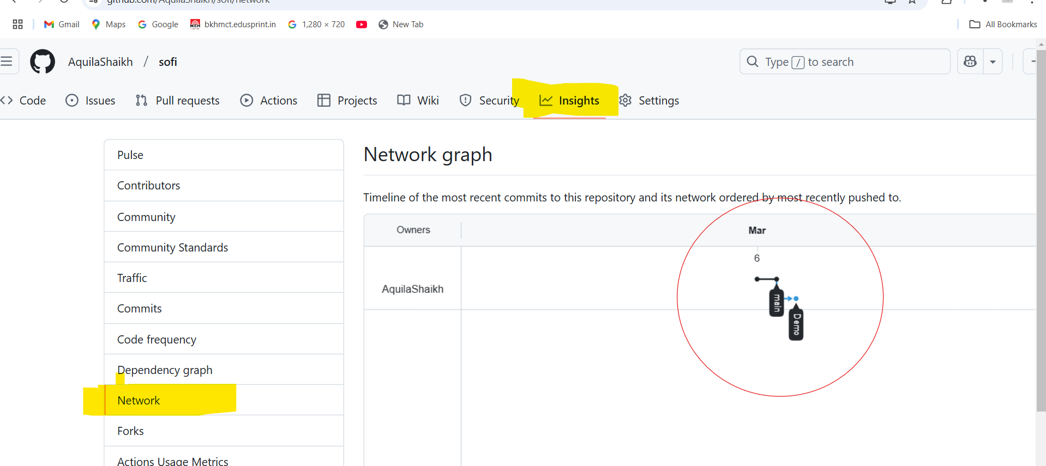
- Now, Suppose you have something in “Main” but not in “Demo”
- To avoid such confliction, we perform Merge operation.
  - Go to “Main” branch
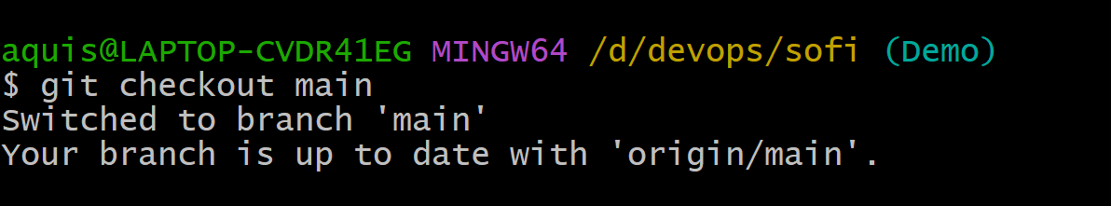
  - Perform merge operation
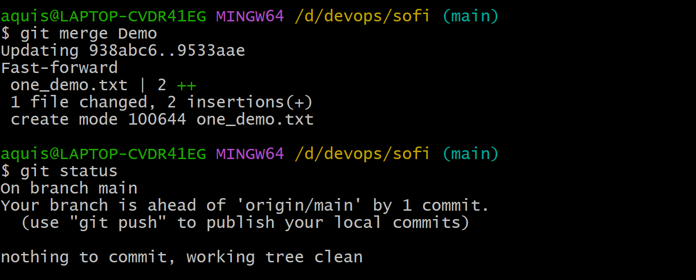

  - Push origin “main”
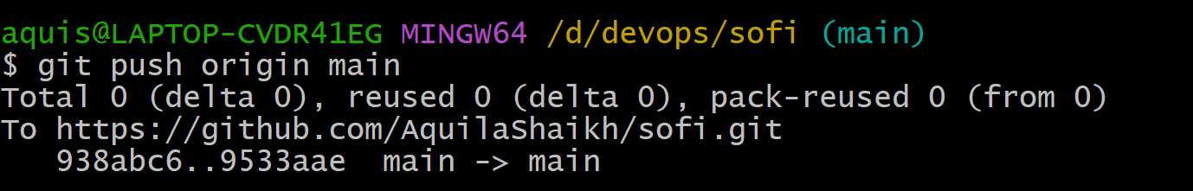

- You will see the branch merging in insight→network.

